
Information Centre
Hopkins Street from Consumers Drive to Dundas Street,
Town of Whitby

Notice of Study Commencement and Public Information

Works Department May 27, 2026 Public Notice

The Regional Municipality of Durham is initiating a Municipal Class Environmental Assessment
(MCEA October 2000, as amended in 2024) for the reconstruction and widening of Hopkins Street (Regional Road 36) from Consumers Drive (Regional Road 25) to Dundas Street to include a two-way centre turning lane and a grade separation at the Canadian Pacific Kansas City (CPKC) rail corridor, in the Town of Whitby (see map).
The Hopkins Street widening for a two-way centre turning lane and a grade separation at the CPKC rail corridor was identified in the Durham Transportation Master Plan 2017 (TMP) as the preferred solution to address operational deficiencies, road safety, active transportation infrastructure and increasing traffic volumes. Phase 1 (Identify the Problem or Opportunity) and Phase 2 (Identify Alternative Solutions and Establish the Preferred Solution) of the MCEA planning process were satisfied through the TMP and reconfirmed through background work conducted for this Study. The TMP is available at durham.ca/TMP.
This Study will proceed in accordance with Schedule ‘B’ MCEA planning process. The next part of this Study is to present preferred solution for the reconstruction, and two-way centre left-turn lane widening of Hopkins Street including intersection modifications and a proposed grade separation within the Study Area.
Public Information Centre
A key component of the Study is consultation with interested parties and the public, and we want to hear from you. A Public Information Centre (PIC) will be held to present the preferred design solution. You will also be able to review the presentation and provide feedback. The PIC will be held:
Date: June 10, 2026, from 6to 8:30 p.m.
Location: Anderson CVI School, 400 Anderson Street, Whitby, ON, L1N 3V6
(see map on page 2)
Starting June 11, 2026, the material presented at the PIC will be posted at durham.ca/HopkinsStreetEA.
If you are unable to attend the PIC, please review the PIC material and submit your comments using the Comment Form that will be available on the website. Comments are requested by July 3, 2026.
At the conclusion of the Study, project findings will be documented in a Project File Report, which will be made available for a 30-day review period. A Notice of Study Completion will be issued to inform the public of the Project File Report’s availability.
Please note under the Municipal Freedom of Information and Protection of Privacy Act and the Environmental Assessment Act, unless otherwise stated in this submission, any personal information included in a submission will become part of the public record files for this matter and will be released, if requested, to any person.

Key Map
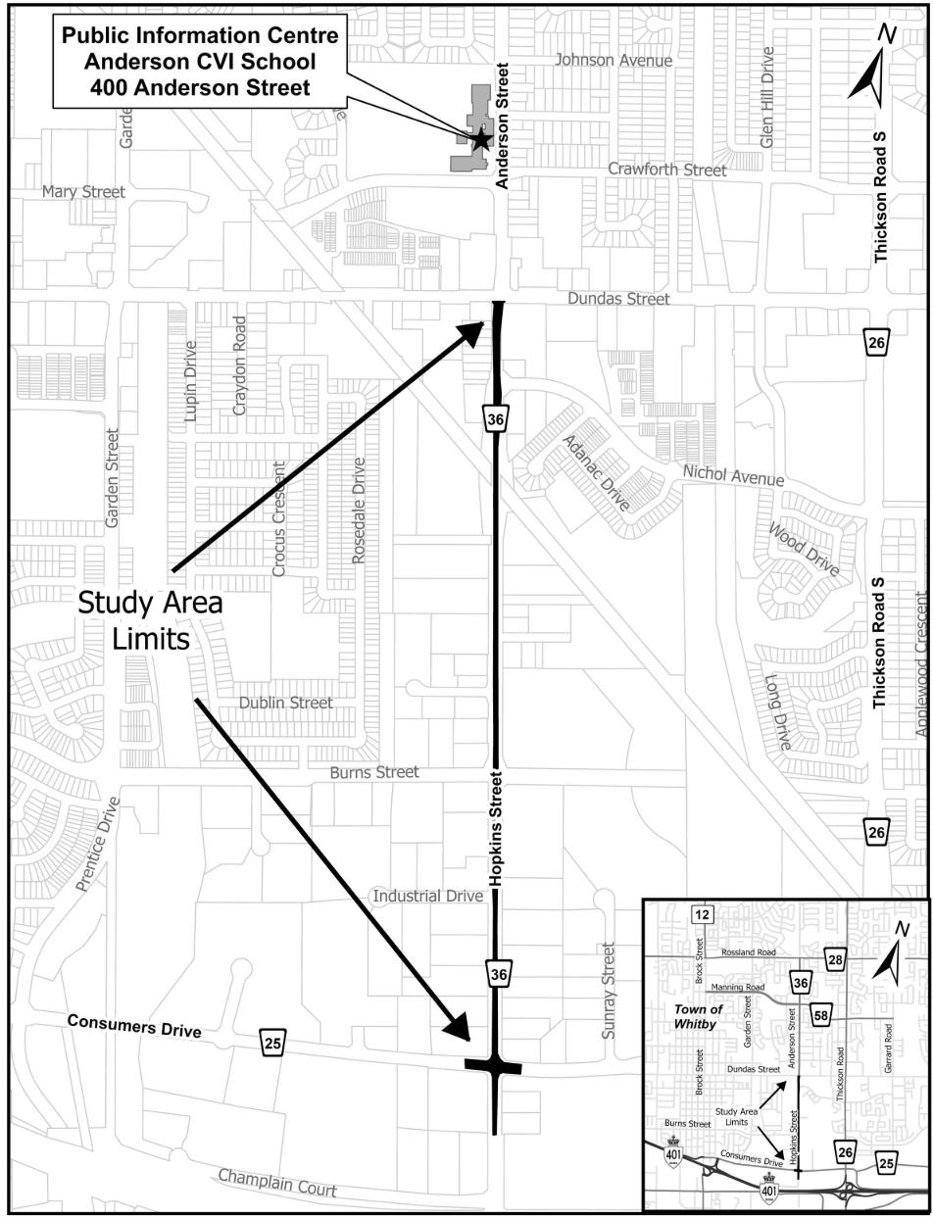

Should you wish to be added to the Study contact list or have any questions or concerns, please contact the following staff member from the Regional Municipality of Durham, Works Department:

Bino Varghese, P.Eng.
Senior Project Manager, Transportation Infrastructure Design
905-668-4113 ext. 3259
Bino.Varghese@durham.ca

If you require this information in an accessible format, please contact 1-800-372-1102 ext. 2848.

Follow the Region on social media @RegionOfDurham

